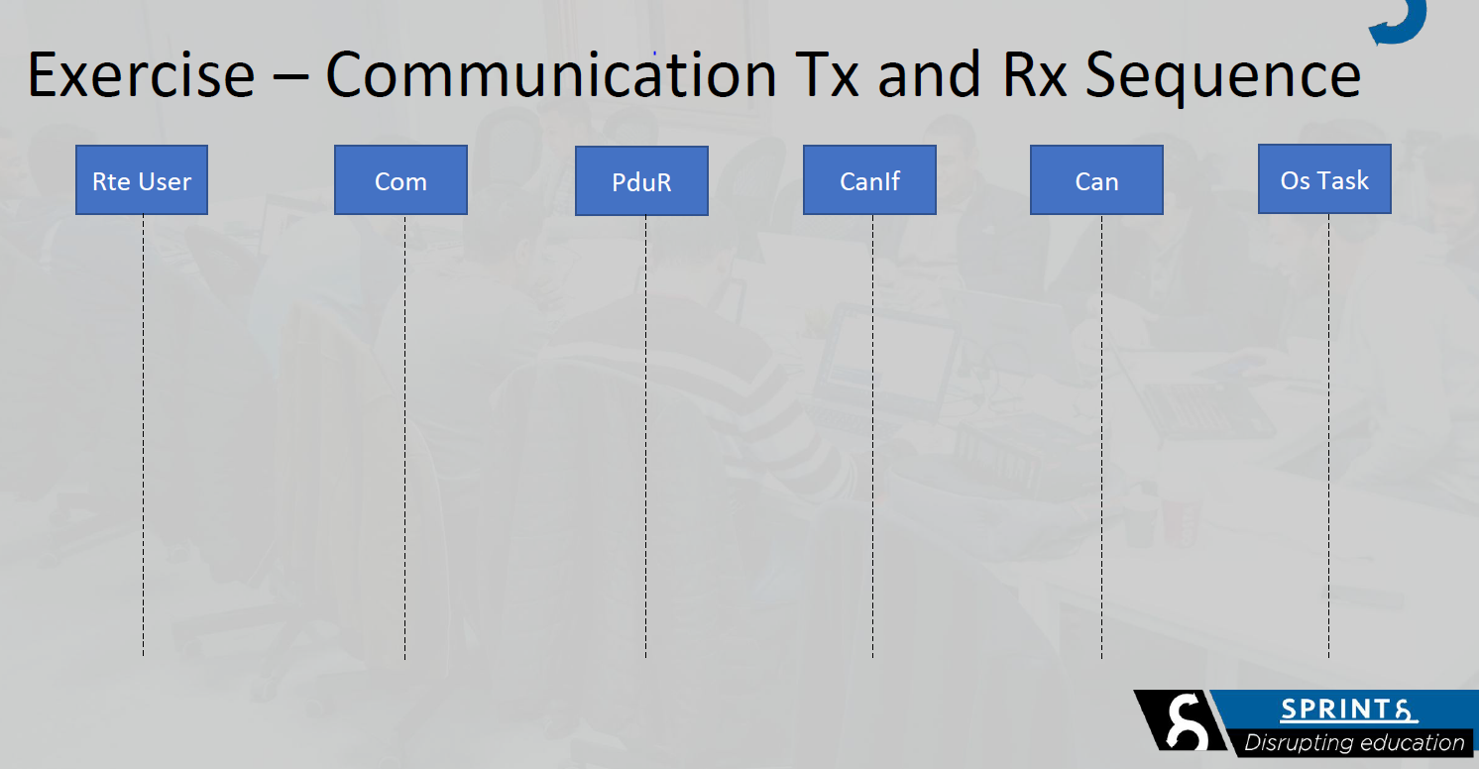

PduR_<User:Lo>RxIndication

Com_ReceiveSignal

Com_RxIndication

CanIf_RxIndication

Rx

TX

Can_Write

CanIf_Transmit

PduR_ComTransmit

Com_SendSignal